Our Safeguarding Policy

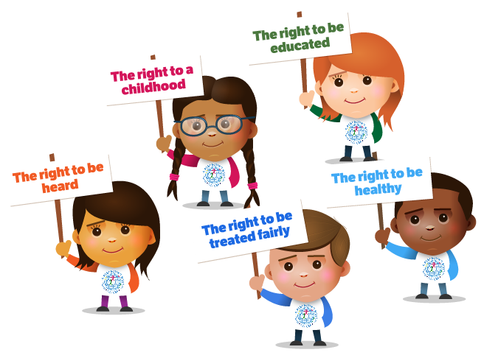
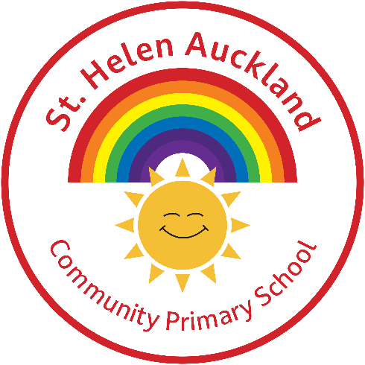

All children and young people have the right to feel safe.

When we feel safe we usually feel good about ourselves.

We can relax and enjoy life.


What is this?

Our school has a special plan called a safeguarding policy. This plan is for teachers, families, and important school helpers. It is made for children like you in primary school.

What is it for?
This policy helps you understand problems and shows you who can help. St Helen Auckland Community Primary School is your school, and we want it to be a safe place for you. The adults at school will do everything they can to keep you safe and happy. They follow many rules to help keep you protected. This policy helps you learn what safeguarding means and tells you what to do if you notice a problem or need help.

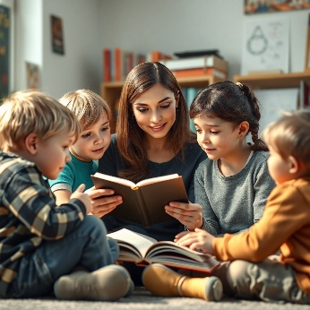
The adults in school believe that safeguarding means:
- Keeping you safe from harm
- Helping you stay healthy and grow well
- Looking after you properly
- Giving you the best chances to be happy and successful in life

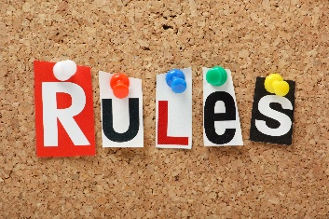
They promise to:
- Make our school a friendly and welcoming place for you
- Be there for you to talk to if you need help
- Teach you how to stay safe at school and online
- Follow all the important rules to protect you
They will follow these rules all the time (these rules are sometimes called policies).

Abuse
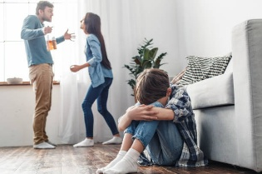
Abuse is when someone hurts you on purpose. It can be:
- If someone hits or hurts you in any way.
- If someone says or does something that makes you feel bad, scared, or sad.
- If you see someone shout or hurt someone you care about, and it makes you feel worried.
- If someone does not take care of you properly, and you feel lonely or neglected.
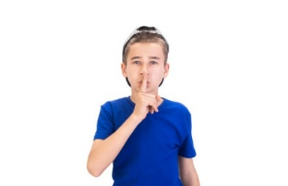
- If someone touches you in a way that makes you feel uncomfortable or scared, or shows you things that make you feel bad.
If you are being hurt, remember it is not your fault. You should always tell someone about it so they can help you.

In and Out of School
All the adults at St Helen Auckland Community Primary will keep you safe at school. They will know who is at school by asking visitors to sign in. Visitors will wear a badge, so you know who they are. People we do not know cannot be with you alone or walk around the school without a teacher.
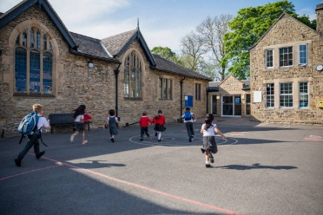
The school will be safe for you, but accidents can happen if you are not careful. If there is a fire drill, staff will help you. If you go on a school trip, they will also keep you safe.

What we will do
At our school, we will help you in these ways:
- We will try to notice if you have a problem.
- We will work with others to help protect you.
- We will listen to you when you need help.
- We will support you and respect what you think.
You can talk to any teacher or staff member in school, but there are special staff who take care of your safety. They will make sure you are safe and well cared for.
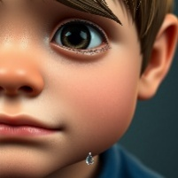
Remember:
- If someone is hurting you, it is not your fault.
- There is always someone who can help.
- If someone is hurting you, it might hurt others too, so you must tell someone.
- Every child deserves to be happy and safe at school.
Do not be scared to tell someone right away. We will always listen to you!

Tips for Keeping Yourself Safe
Bullying:
If you think someone is bullying you or a friend, tell your parents, a teacher, or someone you trust.
If Someone Says Something Upsetting:
Tell your parents, a teacher, or someone you trust if you hear or see something that makes you feel bad.
Touching:
Your body is yours! If someone touches you where you do not like, tell your parents, a teacher, or someone you trust.
Getting Hurt:
If someone hits or hurts you, tell your parents, a teacher, or someone you trust.
Secrets:
Some secrets can be fun, but not all. If someone asks you to keep a bad secret, tell your parents, a teacher, or someone you trust.

Presents:
Presents can be lovely, but check with your parents before accepting gifts from others. Sometimes people give gifts to trick children. If something feels wrong, let someone know.
Online Safety:

Computers and phones are great, but they can also be risky. At St Helen Auckland Community Primary, we have rules to keep you safe online. If you see something that makes you unhappy, tell a trusted adult or visit CEOP.

People in School Who Can Help You
- Your Class Teacher
- Teaching Assistants
- Mrs Elmes
- Mrs Brown
- Miss Parker
- Any other adult in school

Useful Numbers and Websites
Childline: 0800 11 11
Remember, you are never alone. We are here to help you!

