
EYFS/School Brochure
2026/2027
“Smiles are the norm; lessons are fun and interesting”

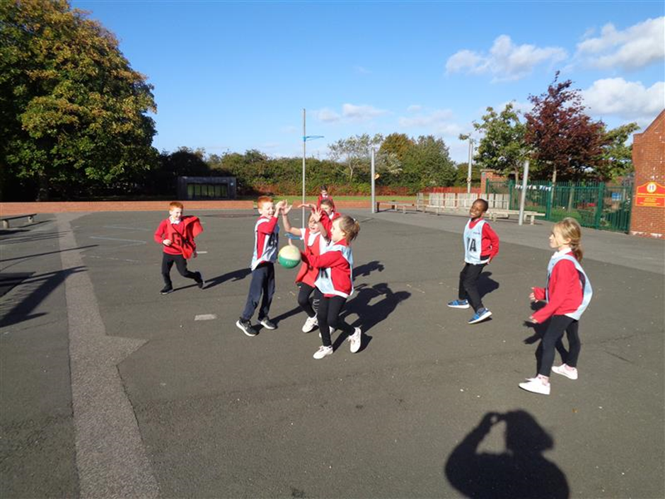

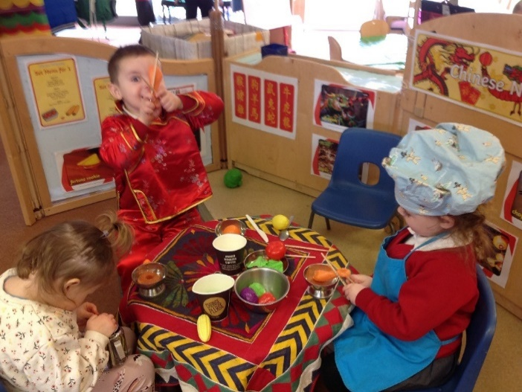

St Helen Auckland Community Primary School

Leave Blank
CONTENTS

Welcome to St Helen Auckland Community Primary............................................................................. 2

St Helen Primary School Governors................................. 3

Staff .................................................................................. 4

General Information/ The School Day ............................. 6

Our School Aims……………………………................................. 7

Starting nursery .............................................................. 8

Clothing/School Uniform …………...................................... 9

Early Years curriculum..................................................... 10

Additional support ...……………………………………………………12

School meals...………………………………………………………………13

Homework ………. ........................................................... 14

Useful information. ………………………………………………………15

Attendance …………………………………………………………………16

Medical................................... ……………………………………...17

Behaviour ......................................................................... 18

Policies ………………………. .................................................. 19

Dear Parent/Carers,

On behalf of the staff and governors I welcome prospective pupils and new pupils and parents to the school.

We want children to be happy and enjoy their time at St Helen Auckland Community Primary School. We have dedicated, enthusiastic staff who are passionate about children’s education.

The Governors are proud that excellent teachers, supported by knowledgeable and skilled support staff, teach all of our children. This was ratified by our last Ofsted inspection (October 2018) describing teachers as

‘..skilled with high levels of subject knowledge. They know their pupils well and use this knowledge to focus their teaching on the learning needs of individuals and groups of pupils’.

Ofsted talked about Support Staff who ‘support pupils effectively and remove barriers to their learning by keeping them on track and focused on the task in hand’

Our children are educated in a stimulating and supportive environment. We aim for all our children leave us as well rounded, happy and confident individuals who are socially, academically and emotionally ready for the next phase of their learning and life as adults.

We believe that successful education relies on an effective partnership between home, school and community. We value parental support and you are always welcome to contact school if you have any concerns or worries.

Mrs J Elmes

Headteacher

Manor Road

St Helen Auckland

Bishop Auckland

Co Durham

DL14 9EN

School Governors
Leanne Harris – Chair of Governors/ parent

TBC – Vice Chair or Governors/ Co-opted

Heather Airey- Staff Governor

Melody Hockaday- Co-opted

Linda Nicholls - Co-opted

Mrs Reyan Clarey – Co-opted

Mr Mark Carey – Co-opted

Valerie Hindmarsh – Local Authority Governor

Mrs G Lumsden- Co-opted

Staff/ Responsibilities
Mrs J Elmes (SLT) Headteacher
Designated Safeguarding Lead/ CLA / Data

Mrs H Airey Nursery / Teacher
EYFS lead/ SEN support

Mrs S Thompson Reception teacher/ Phonics lead/ Wellbeing lead

Mrs P Spark-Davies Year 1 Teacher/ Behaviour lead
Phonics lead

Mrs R Walker Year 2 teacher

Mrs L Brown (SLT) Deputy Head/ Attendance lead, SENCO/
Deputy Designated Safeguarding

Miss A Tindale Year 4 Teacher

Miss J Parker (SLT) Year 5 Teacher
Deputy Designated Safeguarding
Teaching and learning lead

Mrs B McGeary(SLT) Year 5/6 Teacher English Lead

Support Staff
Mrs P Bayes Support Staff
Miss M McGowan Support Staff
Mrs K Gauchi Support staff
Mrs J Hardwick Support staff
Miss G Sumpton Support staff
Mr S Brentnall Support staff
Mrs V Brown Support staff
Miss J Owen Support staff
Miss A Bradford Support staff
Miss E Hall Support staff
Mrs L Slater Support staff
Miss B Jardine Apprentice

Office Staff
Mrs M Bostock Business Manager
Miss B Dixon Office Admin

Other roles in school
Caretaker Mr P Wakefield
Cleaners Mr V Coglan , Mrs S Raine
Lunchtime supervisors Mrs P Graver, Mrs L Tray

General information
This brochure sets out information about St Helen Auckland Community Primary School. If you need further clarification or information about any information please do not hesitate to contact school. You can also visit our website - www.sthelenauckland.durham.sch.uk.

I hope this gives you the information you need to reassure you.

Our school caters for 2 yr olds to 11 years in a single building. The front of the building is the existing school but the school now extended to cater for growing classes. We currently have one form entry and have 8 classes. We have a large playground and school field. We also have built ‘a qube’ on the field which is used for outdoor activities.
The school day 2022-2023
We open the gate at 8.50 and it is important that all children are in ready to start work for 9.00

Breakfast club 8.00 - 8.50
Morning session 8.50 - 12.00
LowerKS2 8.50 - 12.20
Upper KS2 8.50 - 12.30

Afternoon session 12.50 - 3.10
KS 2 1.00 - 3.10
2 year old provision and Nursery
Morning session 8.50 - 11.50
Afternoon session 12.15 - 3.10
30 hours 8.50 - 3.10

We also provide costed breakfast club in nursery 8.00-8.50. We provide extra after school care (costed sessions )3.15-4.15
School Aims

Everyone must follow our school rules ;

We care for each other
We care for our school
We always do our best.

- Everyone has a duty to treat others with respect.
- Everyone has a duty to look after equipment and other people’s property
- Everyone has a right to be safe in school
- Everyone has a right to broad and balanced curriculum.

Staff are always here if you would like to talk about your child, ask any questions or discuss any problems. You know your child best and it is important to share information.
If you have any worries or concerns you would like to share please contact
Mrs Janet Elmes ( Headteacher)
Mrs Airey( Nursery/ Reception Teacher/Early Years Lead)
If you would like to make an appointment please contact Mrs Bostock – Business Manager and this will be arranged.

Creating the Foundations
Entering foundation stage is often a child’s first venture into the outside world alone. The experiences and opportunities they have can create strong and lasting foundation on which to build. We believe these experiences must be of the highest quality. By working with parents we aim to provide a stimulating and challenging environment which is warm and friendly. An environment where adults and children have fun, investigate, play, talk, learn and develop.

We are a dedicated team who strive to provide the best opportunities and experiences for your children.


Starting nursery

Although it may be difficult for children and adults to make the separation into the unit, we do our best to ensure your child is happy. Once they are settled a quick goodbye is usually best and gives the reassurance that you will be back.
It is important to collect your child on time- it can be upsetting for a child if they think no-one is coming.

Please ensure your child is seen safely into the school building and staff are aware they are there.

We will ask you to complete a collection list when your child starts nursery. For safeguarding reasons we would not allow your child to go home with someone who is not nominated. If you do require someone else to collect them you can ring the Office Manager and she will pass on a message.

Snack

Children are offered a snack during the day, milk, water and fruit. This is monitored by staff.

Clothing
If your child is in nappies please discuss with the staff how you are approaching potty training. Also please ensure clothing is easy for children to get on and off to use the toilet or change a nappy.



We will help children to put their coat on and take it off but encourage them to have a go themselves. Please remember warm clothes in winter and a sun hat in summer.

We do encourage children in nursery and reception to wear a uniform. In reception children have PE once a week and will require a PE t shirt and shorts.
PLEASE put your child's name in clothing as it can be difficult to find missing jumpers etc.
School uniform
We have a school uniform at St Helen which consists of red jumper or sweatshirt, white shirt or polo shirt , grey or black pinafore or grey/black trousers, skirt or leggings. In the Summer pupils can wear grey or black shorts or a red and white gingham dress. We also ask that children we suitable clothing for PE, white polo shirt and black or grey shorts, leggings or jogging bottoms. Children come to school in PE kit on the days they have PE.

The wearing of jewellery is not allowed. This can be dangerous during PE or playing on the yard. If children wear jewellery this is limited to a watch or a small pair of stud earrings which must be removed for PE or studs covered with a plaster.

Jewellery
Children should not wear any jewellery in Foundation stage for health and safety reasons. If children have ears pierced then a small stud is allowed however this will have to be covered with a plaster for PE or removed by parents or the child.
Early Years Curriculum
Young children learn from everything around them. The Early Years curriculum looks at different aspects of this journey.

  - Personal, Social and Emotional Development:
- Making relationships
- Self-confidence and self-awareness
- Managing feelings and behaviour

  - Communication and language and literacy
- Listening and Attention
- Speaking
- Understanding

  - Physical Development
- Moving and Handling
- Health and Self Care

  - Literacy/Maths
- Reading/Writing
- Number /Shape, space and measure

  - Understanding the World
- People and Communities
- The World
- Technology

  - Expressive Art and Design
- Exploring and using media and materials
- Being Imaginative

English
English in school is based on real life texts. Each half term a book is chosen to base this work on. Each class also has a class novel and teachers read to them daily.
Reading is very important to us at St Helen. Children are encouraged to read at home and are listened to in school at least 3 times a week.

Phonics is taught in school using Little Wandle. Parents can access videos to support their children.
Speaking and listening
We want to develop confident children who can express themselves with clarity. We encouraged pupils to adapt their vocabulary according to purpose, listeners and context. Part of this is also being a good listener.

Personal, Social, Citizenship and Health Education
Heartmath is used in school as a means of calming down and preparing ourselves for the day. It helps us to concentrate and be ready for learning.
Children are listened to and their views are respected. We have a group of children who make up the school council and also the eco council.
Positive play is encouraged in school. Staff use a restorative approach to dealing with conflict.
Careers education is taught through the subjects in each class.
Explicit opportunities to promote pupils’ development in SMSC are provided through the teaching of RE and PSHE as well as through the school’s ethos, effective relationships and collective worship.

Sex Education
RSHE is taught through our PSHE and science curriculum.

Additional support
Some children will need additional support or adapted work to support their learning. This would be discussed with you and any support put in place. If you child is being seen by outside agencies we will receive copies of the reports to discuss with you.

We also have a member of staff who provides social programmes and therapeutic work for individual children. Parents are encouraged to discuss any concerns with a member of staff if you think any of this work would benefit your child.

If your child has any SEN needs, Mrs Elmes/ Mrs Brown/ Mrs Airey will be available to discuss your child’s needs to ensure these can be met in school.

School meals

School meals are cooked and served on the premises and are available to all children, reception to year 6. Children can choose from a 3 week rotating menu. Please check the current price of a school lunch with the office. Dinner money is paid via Parent pay. You will be asked to complete a FSM verification form and if your child is entitled to free school meals we will be informed.

All children in reception and KS1 will receive a free school meal. Please remember when your child goes into Year 3 you may be required to pay.

Children can also bring a packed lunch into school. A list of what can be included in this meal is available from the office. Please do not send hot drinks or glass bottles. Children are not allowed to bring sweets to school.

If children are changing from packed lunch to school meals or vice versa we need at least one week notice in order for the kitchen staff to adjust food orders.

If your child has a special diet, please let us know and we will ensure you are contacted by our catering team to ensure they have a menu suitable for them.

Homework
We actively encourage all parents to be involved in the day to day operation of our homework policy. This starts in nursery and goes onto year 6. The role of parents and the range of activities obviously changes as you support your children through school.

It would help you child if you could:

Provide a suitable place for them to do their homework.

Show your child how important homework is and how it helps their work in school

Praise your child when they have finished a task

Be involved, especially with the activities of younger children, listen to them read, play games.

Useful information
Money and valuables

St Helen is now a cash free school. When your child joins our school you will be given a log in for ‘Parent Pay’. This is how you can pay for breakfast club, school lunches, after school clubs etc. We also use this to communicate via email.

Children are encouraged not to bring valuables into school. We cannot take responsibility for loss or damage to personal property.

Drop off and collection

Morning and afternoon drop off and collection are really busy times in school and outside the school gate. Please try to park sensibly and consider other parents and children. Remember a child’s life could be at risk if care if not taken.

The gates will be opened at 8.40 until 9.00 and we request that you drop children off at the main gate. Any messages will be taken by staff on the gate and passed onto the relevant people.

The gates will be opened again at 3.10 until 3.15. We do operate a queueing system in school to collect your children to ensure they are safely passed over to the appropriate adult. Again, any messages should be given to staff on the gate as staff on the door are responsible for other children and cannot give you their full attention.

Attendance
In order to comply with the 2006 Education Act, term time absence will not be authorised except in exceptional circumstances. See attendance policy.

If your child is absent from school, please inform the office before 9.05 by telephone. Schools must differentiate between authorised and unauthorised attendance must be reported. Senior Leaders regularly analyses attendance and if this gives cause for concern we will contact you to discuss this matter further. We would encourage all parents to try to take breaks during holidays to minimise disruption to your child’s education .

Medical
Parents are requested to inform school about any medical conditions your child may have. If your child becomes unwell while in school we will contact you. Can you ensure we always have upto date contact details. In the case of an accident first aid will be administered, if it is a facial injury or head bump, we will phone home to let you know, other wise for minor injuries a message will be sent via Medi- tracker.

If your child has been given a prescribed medicine our first aiders are able to administer this but parents must complete a form to give permission and medicine must be handed to an adult daily. This will be for children who have to be medicine administrated 3/4 times a day.

If your child is asthmatic parents must sign a permission slip and an inhaler kept in school.

For children with more serious medical conditions we ask that you complete a health care form with medication, signs and symptoms and contact details.

All children with ongoing medical conditions will require an IHP (Individual Health Plan) to ensure their needs are met and monitored in school.

Behaviour
Our approach to behaviour at St Helen is one of fairness with a huge regard to what is right and wrong. All children are expected to show consideration, courtesy and respect to children and adults at all times. We encourage honestly and respect for possessions and property of other people and the school.

Behaviour is rewarded in school with:

- Celebration assemblies
- Positive encouragement by staff
- Well done stickers.
- Restorative approach

Sometimes this positive approach needs reinforcement. A message will be sent home to parents explaining the behaviour and actions taken. This may mean losing certain privileges in school. Hopefully the liaison between home and school will result in an improvement in behaviour.

Policies

Our policies reflect legislation and local authority guidance. They have been agreed with governors. Copies of policies are available in school and a number of them are on the school website.

We will ask you to sign to say you have read some of the relevant policies.

Complaint procedure
We believe parents have the right for any complaint to be dealt with quickly, fairly and with the minimum of stress.

The vast majority of complaints can be dealt with quickly, usually by teachers.

If the complaint is more serious then an appointment should be made with the Headteacher.

If the matter still cannot be resolved you can speak initially to the Chair of Governors which will advise you if you need to take this further or can be dealt with by themselves. Our relationship with parents is important to us, we want children to be happy in school and do not want anything affecting this. Please help us to support you and your child by contacting us early if you have any worries or concerns.

